Batch:___B2_____ Roll No.:____1611103__
Experiment No. 10
Grade: AA / AB / BB / BC / CC / CD /DD

Title: Implementation of Graph menu driven program for DFS and BFS.

Objective:

Expected Outcome of Experiment:

CO | Outcome
1 | Explain the different data structures used in problem solving.

Books/ Journals/ Websites referred:

1. Data Structures A Psedocode Approach with C, Richard F. Gilberg & Behrouz
A. Forouzan, second edition, CENGAGE learning.
2. C & Data Structures By O. G. Kakde

Abstract:-
A graph is a structure made of two components: a set of vertices V, and a set of edges
E. Therefore, a graph is G = (V,E), where G is a graph. The graph may be directed or
undirected. In a directed graph, every edge of the graph is an ordered pair of vertices
connected by the edge, whereas in an undirected graph, every edge is an unordered pair
of vertices connected by the edge.
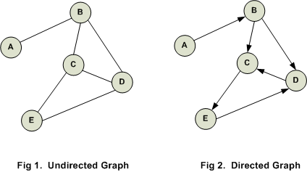

Directed edge: A directed edge between the vertices vi and vj is an ordered pair. It is
denoted by <vi,vj>.

Undirected edge: An undirected edge between the vertices vi and vj is an unordered
pair. It is denoted by (vi,vj).

Types of Graph:
-Simple graph
-Undirected or directed graphs
-Cyclic or acyclic graphs
-Labeled graphs
-Weighted graphs
-Infinite graphs

Representation of a Graph in Memory:

Adjacency Matrix:
Adjacency Matrix is a 2D array of size V x V where V is the number of vertices in a graph. Let the 2D array be adj[][], a slot adj[i][j] = 1 indicates that there is an edge from vertex i to vertex j. Adjacency matrix for undirected graph is always symmetric. Adjacency Matrix is also used to represent weighted graphs. If adj[i][j] = w, then there is an edge from vertex i to vertex j with weight w.
The adjacency matrix for the above example graph is:
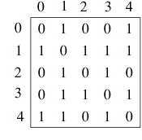
Pros: Representation is easier to implement and follow. Removing an edge takes O(1) time. Queries like whether there is an edge from vertex ‘u’ to vertex ‘v’ are efficient and can be done O(1).
Cons: Consumes more space O(V^2). Even if the graph is sparse(contains less number of edges), it consumes the same space. Adding a vertex is O(V^2) time.
Adjacency List:
An array of linked lists is used. Size of the array is equal to number of vertices. Let the array be array[]. An entry array[i] represents the linked list of vertices adjacent to the ith vertex. This representation can also be used to represent a weighted graph. The weights of edges can be stored in nodes of linked lists. Following is adjacency list representation of the above graph.

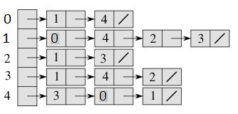

Pros: Saves space O(|V|+|E|) . In the worst case, there can be C(V, 2) number of edges in a graph thus consuming O(V^2) space. Adding a vertex is easier.
Cons: Queries like whether there is an edge from vertex u to vertex v are not efficient and can be done O(V).
Related Theory:-
Algorithm of DFS:

Step1: n ← number of nodes
Step2: Initialize visited[ ] to false (0)
Step3: for(i=0;i<n;i++)
visited[i] = 0;
Step4: void DFS(vertex i) [DFS starting from i]
{
visited[i]=1;
for each w adjacent to i
if(!visited[w])
DFS(w);
}
Step5:Exit

Algorithm of BFS:

Step 1: SET STATUS = 1 (ready state)
for each node in G
Step 2: Enqueue the starting node A
and set its STATUS = 2
(waiting state)
Step 3: Repeat Steps 4 and 5 until
QUEUE is empty
Step 4: Dequeue a node N. Process it
and set its STATUS = 3
(processed state).
Step 5: Enqueue all the neighbours of
N that are in the ready state
(whose STATUS = 1) and set
their STATUS = 2
(waiting state)
[END OF LOOP]
Step 6: EXIT
Code:-
#include <stdio.h>
#include <stdlib.h>
int visited[10],adj[10][10],n,c,front=0,rear=0,q[10];
void bfs(int);
void dfs(int);
int main()
{
int ch,i,j;
while(1)
{
printf("Select any one of the choices given below\n");
printf("1. DFS and BFS traversal\n");
printf("2. Exit\n");
printf("Response: ");
scanf("%d",&ch);
if(ch<=3)
{
switch(ch)
{
case 1:
printf("Enter the no of nodes in the graph: ");
scanf("%d",&n);
printf("Enter the adjacency matrix\n");
for(i=0;i<n;i++)
{ for(j=0;j<n;j++)
{
scanf("%d",&adj[i][j]);
}
}
for(i=0;i<10;i++)
visited[i]=0;
printf("DFS TRAVERSAL\n");
dfs(0);
printf("\n");
for(i=0;i<10;i++)
visited[i]=0;
printf("BFS TRAVERSAL\n");
bfs(0);
printf("\n");
break;
case 2:
exit(0);
break;
}
}
else
break;
}
return 0;
}
void dfs(int p)
{
int i;
printf("%d\t",p);
visited[p]=1;
for(i=0;i<n;i++)
{
if(!visited[i] && adj[p][i]==1)
{
dfs(i);
}
}
}
void bfs(int p)
{
visited[p]=1;
q[rear]=p;
rear++;
while(rear!=front)
{
int i;
int u=q[front];
printf("%d\t",u);
front++;
for(i=0;i<n;i++)
{ if(visited[i]==0 && adj[u][i]==1)
{
q[rear]=i;
rear++;
visited[i]=1;
}
}
}
printf("\n");
}
Output:

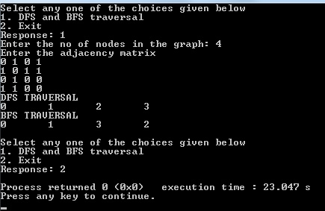

Conclusion:- The program has been executed in C and the output has been verified.

Conclusion:-

